|  |  |  |
| --- | --- | --- |
| **Binario** | **Decimal** | **Hexadecimal** |
| **0101 0000** | 80 | 50 |
| 0111 1000 | **120** | 78 |
| 0011 1101 | 61 | **3D** |
| **1101** | 13 | D |
| 1001 0110 | 150 | **96** |
| **0101 0010 0101** | 2597 | A25 |
| 1011 1111 0011 0000 0101 1010 | 12529754 | **BF305A** |

1B) 0101 0000 = 24 + 26 = **80**  1C) 0101 = 5 - 0000 = 0 = **50**

2A) 7 = 0111 8 = **1000** 2C) 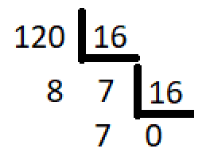

3A) 3 = 0011 D=1101 3D= **00111101**  3B) 3.161 + 13.160 = **61**

4A) 1101 = **D**  4C) 13.160 = **13**

5A) 1001 6 = 0110 96 = **1001 0110** 5B) 9 . 161 + 6 . 160 = **150**

6B) 10.162 + 2.161 + 5.160 = **2597**  6C) 10 = 1010 2 = 0010 5 = 0101 = **A25**

7B) 11.165 + 15.164 + 3.163 + 5.161 + 10.160 = **12529754**

7A) 1011 = B 1111 = F 0011 = 3 0000 = 0 0101 = 5 1010 = A = **BF305A**

2)

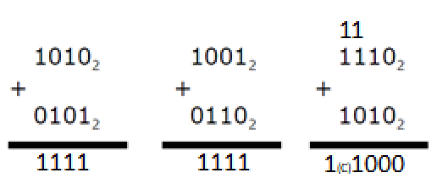

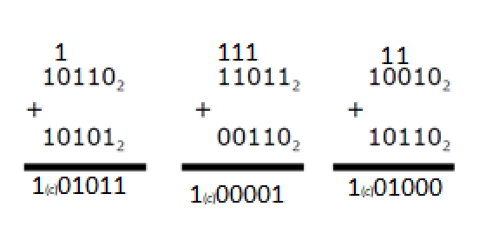

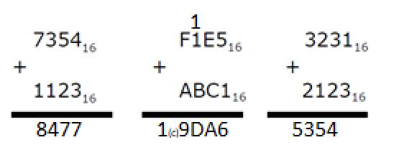

3)

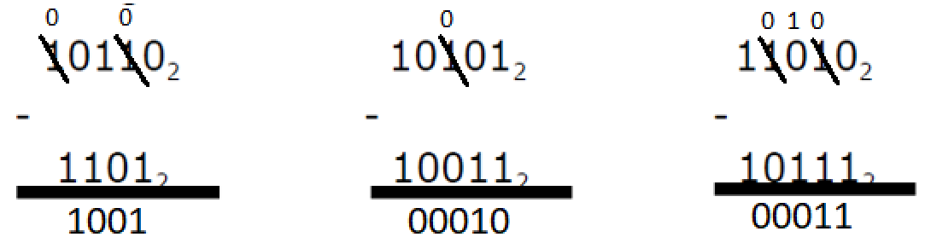

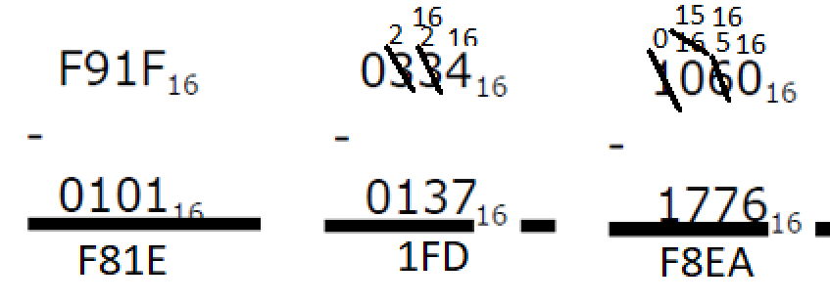

4)

|  |  |  |  |  |
| --- | --- | --- | --- | --- |
|  | **BINARIO** | **SYM** | **COM1** | **COM2** |
| **000** | 0 | +0 | +0 | 0 |
| **001** | 1 | +1 | +1 | +1 |
| **010** | 2 | +2 | +2 | +2 |
| **011** | 3 | +3 | +3 | +3 |
| **100** | 4 | -0 | -3 | -4 |
| **101** | 5 | -1 | -2 | -3 |
| **110** | 6 | -2 | -1 | -2 |
| **111** | 7 | -3 | -0 | -1 |

5)

|  |  |  |  |  |
| --- | --- | --- | --- | --- |
|  | **BINARIO** | **SYM** | **COM1** | **COM2** |
| **0000** | 0 | +0 | +0 | +0 |
| **0001** | 1 | 1 | 1 | 1 |
| **0010** | 2 | 2 | 2 | 2 |
| **0011** | 3 | 3 | 3 | 3 |
| **0100** | 4 | 4 | 4 | 4 |
| **0101** | 5 | 5 | 5 | 5 |
| **0110** | 6 | 6 | 6 | 6 |
| **0111** | 7 | 7 | 7 | 7 |
| **1000** | 8 | -0 | -7 | -8 |
| **1001** | 9 | -1 | -6 | -7 |
| **1010** | 10 | -2 | -5 | -6 |
| **1011** | 11 | -3 | -4 | -5 |
| **1100** | 12 | -4 | -3 | -4 |
| **1101** | 13 | -5 | -2 | -3 |
| **1110** | 14 | -6 | -1 | -2 |
| **1111** | 15 | -7 | -0 | -1 |